Florida COVID-19 Tracker

User Manual

Fabian Martinez

Widler Risin

Nathan Short

# Table of Contents

**Table of Contents** **2**

**Dashboard** **3**

Main Graph (Historical) 4

Detailed Graphs (Current Totals) 5

**Selecting A County** **7**

**Navigation Bar** **8**

**Troubleshooting** **8**

# Dashboard

The Florida COVID-19 Tracker web application is designed to be an intuitive view to COVID-19 cases by county in the state of Florida.

The main screen consists of:

* the Main Graph that provides historical projected and actual totals
* smaller graph that shows current cases by county
* smaller graph that shows current cases in Florida
* smaller graph that shows current cases in the United States
* a map that lets the user select by county
* a navigation bar to other pages

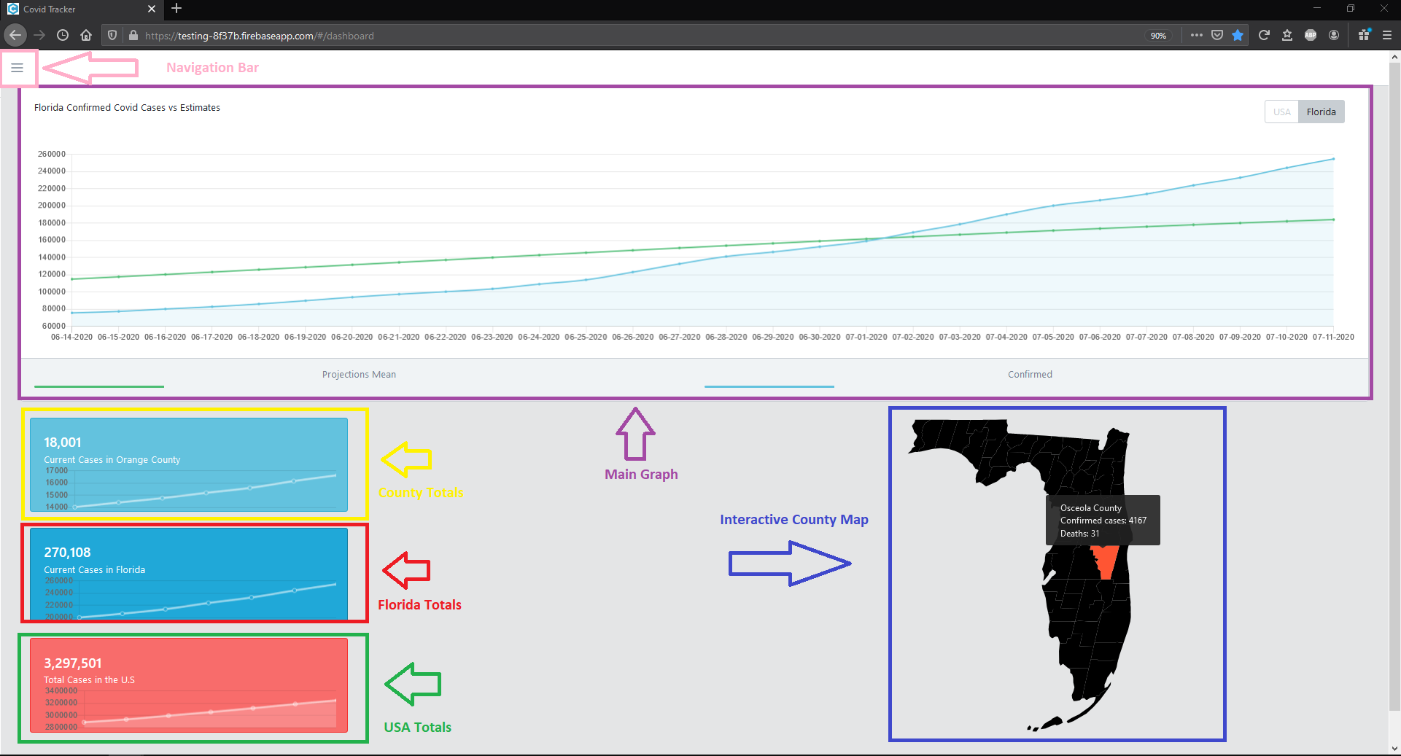

## Main Graph (Historical)

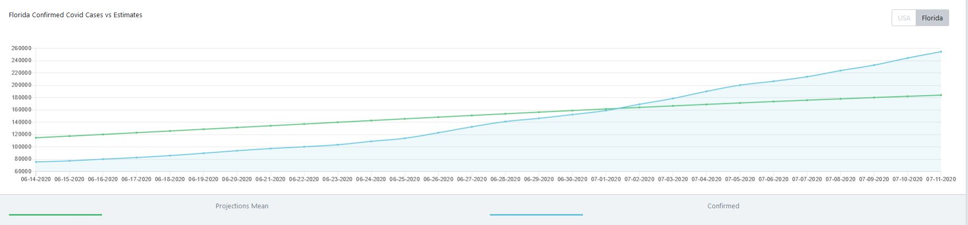

The main graph shows both approximate projections and actual numbers for each day for roughly the last month.

* The green line shows the average projections for a given day.
* The blue line shows actual recorded cases for a given day.

To toggle the data on the graph, user can click on buttons in the top-right corner:

* **[USA]** to view country-wide totals
* **[Florida]** to view totals for the state of Florida -- this is the default selection

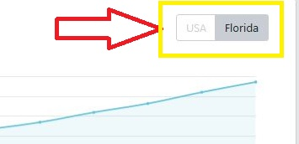

After clicking on the **[USA]** button, the USA totals are displayed instead of the default Florida totals.

## 

## Detailed Graphs (Current Totals)

The three smaller graphs include totals by county, the state of Florida, and the USA:

The first graph shows the totals by county. This graph changes based on the user’s selected county in the Interactive Florida map:

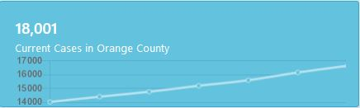

The second graph shows all current cases in Florida:

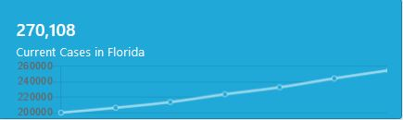

The third graph shows the totals for the USA:

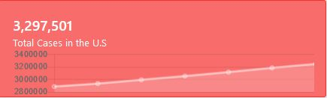

# Selecting A County

The interactive county map contains information for all 67 Florida counties. Hover over any county in the map to view its totals.

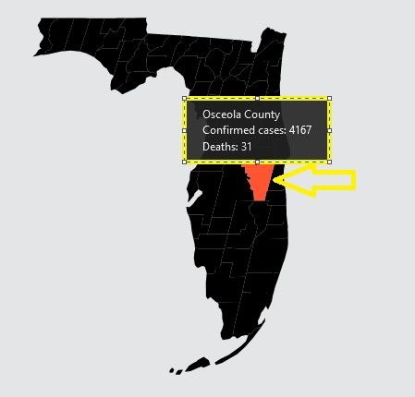

Click on the county to reload the county graph information for the specific county:

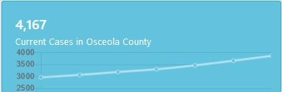

Selecting a new county will also update the name displayed in the navigation bar.

# Navigation Bar

The menu icon in the upper left-hand corner contains a dropdown menu for navigation. This menu updates based on the user’s selected county, and will provide helpful resources based on the selection.

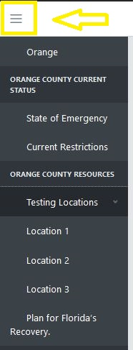

**Note:** At the time of this document writing, the features in the navigation bar have not yet been implemented.

# Troubleshooting

**The graphs do not display any data to the user:**

The COVID-19 Tracker loads large amounts of smaller data to be displayed to the user. Please allow additional time to load on slower internet connections.

**“Enable Javascript to view this webpage” error displays:**

The COVID-19 Tracker relies almost exclusively on JavaScript to work. Please enable JavaScript in your web browser to use the COVID-19 Tracker.